What is a Wireless Sensor Network?
A Wireless Sensor Network is one kind of wireless network includes a large number of circulating, self-directed, minute, low powered devices named sensor nodes called motes. These networks certainly cover a huge number of spatially distributed, little, battery-operated, embedded devices that are networked to caringly collect, process, and transfer data to the operators, and it has controlled the capabilities of computing & processing. Nodes are the tiny computers, which work jointly to form the networks.
Wireless sensor networks (WSN), are similar to wireless ad hoc networks in the sense that they rely on wireless connectivity and spontaneous formation of networks so that sensor data can be transported wirelessly. Sometimes they are called dust networks, referring to minute sensors as small as dust. Smart dust is a U C Berkeley project sponsored by DARPA. Dust Networks Inc., is one of the early companies that produced wireless sensor network products.
WSNs are spatially distributed autonomous sensors to monitor physical or environmental conditions, such as temperature, sound, pressure, etc. and to cooperatively pass their data through the network to a main locations. The more modern networks are bi-directional, also enabling control of sensor activity. The development of wireless sensor networks was motivated by military applications such as battlefield surveillance; today such networks are used in many industrial and consumer applications, such as industrial process monitoring and control, machine health monitoring, and so on. The WSN is built of "nodes" – from a few to several hundreds or even thousands, where each node is connected to one (or sometimes several) sensors.
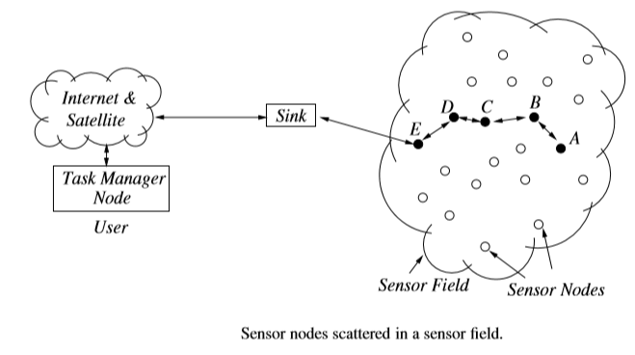
NETWORKED WIRELESS SENSOR DEVICES
There are several key components that make up a typical wireless sensor network(WSN) device:-
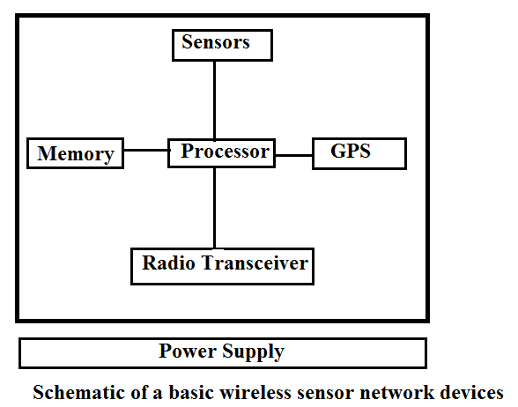
1.Low-Power embedded processor:- The computational task on a WSN device include the processing of both locally sensed information as well as information communicated by other sensors. At present due to economic constraints, the embedded processors are often significantly constrained in terms of computational power. These devices typically runs on embedded OS such as TinyOS.
2.Memory/Strorage:- Storage in the form of Random access and ROM includes both program memory and data memory . The quantities of memory and storage on board a WSN device are often limited primarily by economic considerations.
3.Radio Transceiver:-WSN devices include a low rate , short range wireless radio(10-100kbps,<100m) . while currently quite limited in capability too, these radios are likely to improve in sophistication over time includes improvement in cost, spectral efficiency,tunability and immunity to noise, fading, interference.
4.Sensors:- Due to bandwith and power constraints, WSN devices primarily support only low-data-rate sensing. Many applications call for multi-modal sensing,so each device may have several sensors on board. The sensors used are highly dependent on the application. E.g. they may include temperature, sensors, light sensors, humidity sensors, pressure sensors, accelerometers, magnetometers, chemical sensors, acoustic sensors, or even low –resolution imagers.
5.Geopositioning system:- in many WSN applications , it is important for all sensor measurements to be location stamped.when the network is deployed in an ad-hoc manner for outdoor operation, such information is most easily obtained via satellite-based GPS.However even in such applications only a fraction of the nodes may be equipped with GPS capability , due to environmental and economic constraints, so other nodes may obtain their locations indirectly through network localization techniques.
6.Power Source:- for flexible deployment the WSN is likely to be battery powered(e.g. using LiMH AA batteries). While some of the nodes may be wired to a continuous power source in some applications and energy harvesting techniques may provide a degree of energy renewal in some cases.
Depending on the application, WSN devices can be networked together in a number of ways. In basic data gathering applications, for instance, there is a node referred to as sink to which all data from source sensor nodes are directed. The simplest logical topology for communication of gathered data is a single-hop star topology, where all nodes send their data directly to the sink. In networks with lower transmit power settings or where node are deployed over a large area, a multi-hop tree structure may be used for data-gathering. In this case some nodes may act both as source themselves as well as routers for other sources.
Applications of Wireless Sensor Networks
Various applications of WSN are still very much under active research and development , in both academia and industry.
1.Ecological habitat monitoring:-scientific studies of ecological habitats(animals, plants, micro-organisms) are traditionally conducted through hands-on field activities by the investigators. Due to very presence and intrusive activities of the field investigators may affect the behavior of the organisms in the monitored habitat and thus bias the observer results. Unattended wireless sensor networks promise a cleaner , remote –observer approach to habitat monitoring.
2. Military surveillance and target tracking:-Wireless sensor network originated primarily in military-related research. Unattended sensor networks are envisioned as the key ingredient in moving towards network-centric warfare systems.They can be rapidly deployed for surveillance and used to provide battlefield intelligence regarding the location, numbers, movement, and identity of troops and vehicles and for detection of chemical ,biological, and nuclear weapons.
Much of devt. and research work on WSN has been provided through several programs funded by the US Defence Advanced Research Projects Agency(DARPA) through a program known as SensIT from 1999 to 2002.
3.Structural and Seismic monitoring:- Another class of applications for sensor networks is to monitor the condition of civil structures. The structures could be buildings, bridges, and roads, aircrafts. Unattended networked sensing techniques can automate the process, providing rich and timely information about incipient cracks or about other structural damage. Researchers deploy these sensors densely on the structure either literally embedded into the building material such as concrete or on the surface. Such sensor networks have potential for monitoring the long term wear of structures as well as their condition after destructive events, such as earthquakes or explosions.
4.Industrial and commercial networked sensing:- in industrial manufacturing facilities, sensors and actuators are used for process monitoring and control. E.g. in a multi-stage chemical processing plant there may be sensors places at different points in the process in order to monitor the temperature, chemical, concentration, pressure etc. The information from such real time monitoring may be used to vary process controls, such as adjusting the amount of a particular ingredient or changing the heat settings.
5. Disaster relief applications:- One of the most often mentioned application types for WSN are disaster relief operations. A typical scenario is wildﬁre detection: Sensor nodes are equipped with thermometers and can determine their own location (relative to each other or in absolute coordinates). These sensors are deployed over a wildﬁre, for example, a forest, from an airplane. They collectively produce a “temperature map” of the area or determine the perimeter of areas with high temperature that can be accessed from the outside, for example, by ﬁreﬁghters equipped with Personal Digital Assistants (PDAs).
6. Environment control and biodiversity mapping:- WSNs can be used to control the environment, for example, with respect to chemical pollutants – a possible application is garbage dump sites. Another example is the surveillance of the marine ground ﬂoor; an understanding of its erosion processes is important for the construction of offshore wind farms. Closely related to environmental control is the use of WSNs to gain an understanding of the number of plant and animal species that live in a given habitat (biodiversity mapping).
7. Intelligent buildings:- Buildings waste vast amounts of energy by inefﬁcient Humidity, Ventilation, Air Conditioning (HVAC) usage. A better, real-time, high-resolution monitoring of temperature, airﬂow, humidity, and other physical parameters in a building by means of a WSN can considerably increase the comfort level of inhabitants and reduce the energy consumption (potential savings of two quadrillion British Thermal Units in the US alone have been speculated about.
8. Facility management :-In the management of facilities larger than a single building, WSNs also have a wide range of possible applications. Simple examples include keyless entry applications where people wear badges that allow a WSN to check which person is allowed to enter which areas of a larger company site. This example can be extended to the detection of intruders, for example of vehicles that pass a street outside of normal business hours. A widearea WSN could track such a vehicle’s position and alert security personnel – this application shares many commonalities with corresponding military applications.
9. Machine surveillance and preventive maintenance:- One idea is to ﬁx sensor nodes to difficult to-reach areas of machinery where they can detect vibration patterns that indicate the need for maintenance. Examples for such machinery could be robotics or the axles of trains. Other applications in manufacturing are easily conceivable.
10. Precision agriculture :-Applying WSN to agriculture allows precise irrigation and fertilizing by placing humidity/soil composition sensors into the ﬁelds. A relatively small number is claimed to be sufﬁcient, about one sensor per 100 m×100 m area. Similarly, pest control can proﬁt from a high-resolution surveillance of farm land. Also, livestock breeding can beneﬁt from attaching a sensor to each pig or cow, which controls the health status of the animal (by checking body temperature, step counting, or similar means) and raises alarms if given thresholds are exceeded.
11. Medicine and health care :-Along somewhat similar lines, the use of WSN in health care applications is a potentially very beneﬁcial, but also ethically controversial, application. Possibilities range from postoperative and intensive care, where sensors are directly attached to patients – the advantage of doing away with cables is considerable here – to the long-term surveillance of (typically elderly) patients and to automatic drug administration (embedding sensors into drug packaging, raising alarms when applied to the wrong patient, is conceivable). Also, patient and doctor tracking systems within hospitals can be literally life saving.
12. Logistics :-In several different logistics applications, it is conceivable to equip goods (individual parcels, for example) with simple sensors that allow a simple tracking of these objects during transportation or facilitate inventory tracking in stores or warehouses.
13. Telematics:- Partially related to logistics applications are applications for the telematics context, where sensors embedded in the streets or roadsides can gather information about trafﬁc conditions at a much ﬁner grained resolution than what is possible today. Such a socalled “intelligent roadside” could also interact with the cars to exchange danger warnings about road conditions or trafﬁc jams ahead.
KEY DESIGN CHALLENGES
Wireless sensor networks present a serious challenges that can’t be adequately addressed by existing technologies:-
- Extended Lifetime:- WSN nodes will generally be severely energy constrained due to the limitations of batteries. A alkaline battery provides 50 watt-hours of energy, this may translate to less than a month of continuous operation for each node in full active mode.Given the expense and potential infeasibility of monitoring and replacing batteries for a large network , much longer lifetimes are desired. In practice it is necessary in many applications to provide guarantees that a network of unattended wireless sensors can remain operational without any replacements for several years. Hardware improvements in battery design and energy harvesting techniques will offer only partial solutions.
- Responsiveness:- a simple solution to extending network lifetime is to operate the nodes in a duty-cycled manner with periodic switching between sleep and wake-up modes. Arbitrary long sleep periods can reduce the responsiveness and effectiveness of the sensors.
- Robustness:-The vision of wireless sensor networks is to provide large scale, yet fine grained coverage. This motivates the use of large numbers of inexpensive devices. However inexpensive devices can often be unreliable and prone to failures. Rates of device failure will also be high whenever the sensor devices are deployed in harsh or hostile environments. Protocols designed must therefore have built –in mechanisms to provide robustness.
- Synergy:- Moore’s law-type advances in technology have ensured that device capabilities in terms of processing power, memory, storage, radio transceiver performance and even accuracy of sending improve rapidly.
- Scalability:- For many envisioned applications, the combination of fine-granularity sensing and large coverage area implies that wireless sensor networks have the potential to be extremely large scale(tens of thousands, perhaps even millions of nodes ) . Protocols will have to be inherently distributed, involving localized communication, and sensor networks must utilize some fundamental problems such as failure handling and in-situ reprogramming , are addressed even in small settings involving tens to hundreds of nodes.
- Heterogeneity:- There will be heterogeneity of device capabilities ( with respect to computation, communication, and sensing) in realistic settings. This heterogeneity can have a no of important design consequences. For instance, the presence of small number of devices of higher computational capability along with a large number of low capability devices can dictate a two tier cluster based network architecture and the presence of multiple sending modalities requires pertinent sensor fusion techniques.
- Self –configuration:- Because of their scale and nature of their applications, wireless sensor networks are inherently unattended distributed systems. Autonomous operation of the network is therefore a key design challenge. From the very start, nodes in a wireless sensor networks have to be able to configure their own network topology; localize, synchronize, and calibrate themselves; coordinate inter-node communication; and determine other important operating parameters.
- Self-optimization and adaptation:- Traditionally , most engineering systems are optimized a priori to operate efficiently in the face of expected or well modeled operating conditions. In WSN there may be often be significant uncertainty about operating conditions prior to deployment. Under such conditions it is important that there will be in-built mechanisms to autonomously learn from sensor and network measurements collected over time and to use this learning form sensor and network measurements collected over time and to use this learning to continually improve performance.
- Systematic design:-Wireless sensor networks can often be application specific. There is a challenging tradeoff between ad hoc and more flexible easy to generalize design methodologies that sacrifice some performance.
- Privacy and Security:- The large scale prevalence and sensitivity of the information collected by wireless sensor networks give rise to the final key challenge of both privacy and security.
NETWORK DEPLOYMENT
Deployment is concerned with setting up an operational sensor network in a real world environment. WSN is a system consists of a large no of sensor nodes geographically distributed in the region to be monitored. Placement of sensors in the candidate region is the major factor that determines the coverage , connectivity and life of an WSN.
A number of basic questions must be considered when deploying a wireless sensor network:
- Structured vs randomized deployment
- Over deployment versus incremental deployment
- Network topology
- Homogeneous vs heterogeneous deployment
- Coverage metrics.
STRUCTURED VERSUS RANDOMIZED DEPLOYMENT
The randomized deployment approach is appealing for futuristic applications of a large scale, where nodes are dropped from aircraft or mixed into concrete before being embedded in a smart structure. However in many small-medium-scale WSNs are likely to be deployed in a structured manner via careful hand placement of network nodes. In both cases, the cost and availability of equipment will often be significant constraint.
We can illustrate these issues by considering in detail one possible methodology for structured placement:
- Place sink/ gateway device at a location that provides the desired wired network and power connectivity.
- Place sensor nodes in a prioritized manner at locations of the operational area where sensor measurements are needed.
- If necessary, add additional nodes to provide requisite network connectivity.
Step 2 can be challenging if it not clear exactly where sensor measurements are needed, in which case a uniform or grid like placement could be suitable choice. Adding nodes for ensuring sufficient wireless network connectivity can also be a non trivial challenge, particularly when there are location constraints in a given environment that dictate where nodes can or cannot be placed. If the number of available nodes is small with respect to the size of the operational area and required coverage, a duplicate balance has to be struck between how many nodes can be allocated for sensor measurements and how many nodes are needed for routing connectivity.
Randomized sensor deployment can be even more challenging in some respects, since there is no way to configure a priori the exact location of each device. Additional post deployment self-configuration mechanisms are therefore required to obtain the desired coverage and connectivity. In case of uniform random deployment , the only parameters that can be controlled a priori are the numbers of nodes and some related settings of these nodes,such as their transmission range.
NETWORK TOPOLOGY
The communication network can be configured into several different topologies :-
- Single –hop star
- Multi-hop mesh and grid
- Two –tier hierarchical cluster
- Single-hop star:- the simplest WSN topology is the single –hop star. Every node in this topology communicates its measurements directly to the gateway. Wherever feasible , this approach can significantly simplify design, as the network working concerns are reduced to a minimum . however , the limitation of this topology is its poor scalability and robustness properties. In larger area’s, nodes that are distant from the gateway will have poor-quality wireless links.
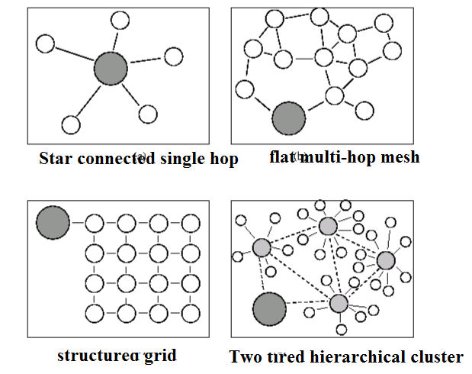
2.Multi-hop mesh and grid:- For larger areas and netoworks, multi-hop routing is necessary. Depending on how they are placed , the nodes could form an arbitrary mesh graph or they could form a more structured communication graph such as 2D grid structure.
3.Two-tier hierarchical cluster:-Perhaps the most compelling architecture for WSN is a deployment architecture where multiple nodes within each local region report to different cluster heads. There are a number of ways in which such a hierarchical architecture may be implemented. This approach becomes particularly attractive in heterogeneous settings when the cluster-head nodes are more powerful in terms of computation/communication. The advantage of hierarchical cluster based approach is that it naturally decomposes a large network into separate zones within which data processing and aggregation can be performed locally. Within each cluster there could be either single hop or multiple hop communication . once data reach a cluster - head they would then be routed through the second tier network formed by cluster heads to another cluster head or gateway.The second tier network may utilize a higher bandwidth radio or it could even be a wired network. If the second tier nodes can all be connected to the wired infrastructure. Having a wired network for the second tier is relatively easy in building like environments but not for random deployments in remote locations. In random deployments there may be no designated cluster-heads; these may have to be determined by some process of self-election.
CONNECTIVITY
- Connectivity in geometric random graphs
The connectivity properties of random deployments can be best analyzed using Random Graph theory. A random graph model is essentially a systematic description of some random experiment that can be used to generate graph instances. These models usually contain a tuning parameter that varies the average density of the constructed random graph .
- Connectivity in G(n,R) :- in a G(n,R) geometric random graph , n nodes are placed at random with uniform distribution in a square area of unit size. There is an edge(u,v) between any pair of nodes u and v, if the Euclidean distance between them is less than R.
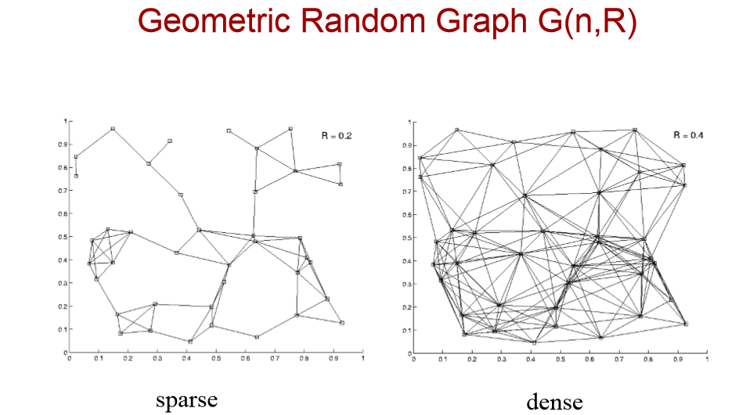
Figure illustrates G(n,R) for n=40 at two different R values. When R is small , each node can connect only to other nodes that are close by , and the resulting graph is sparse; o the other hand a large R allows longer links and results in a dense connectivity.
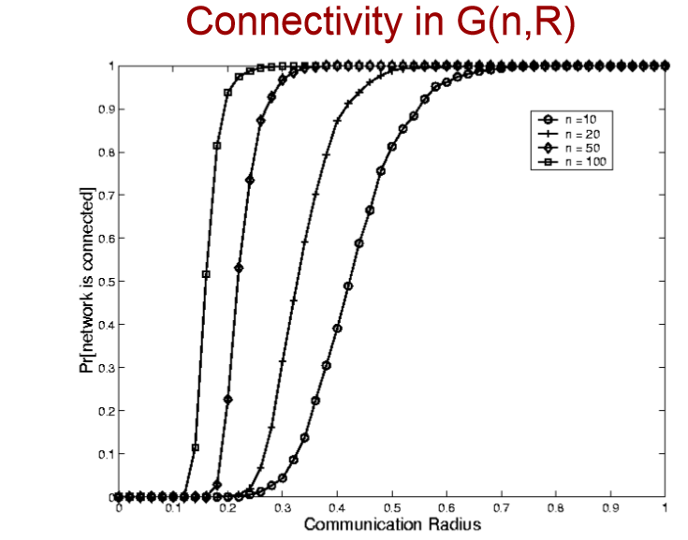
Figure above shows how the probability of network connectivity varies as the radius parameter R of a geometric random graph is varied. Depending on the no of nodes n, there exists different critical radii beyond which the graph is connected with high probability. These transitions become sharper (shifting to lower radii) as the number of nodes increases.
2.Monotone properties in G(n,R):- A monotonically increasing property is any graph property that continues to hold if additional edges are added to a graph that already has the property. A graph property is called monotone if the property or its inverse are monotonically increasing.nearly all such graphs such as k-connectivity, Hamiltonicity,K-colorability etc are monotone.
3.Connectivity in G(n,K):- Another geometric random graph model is G(n,K) where n nodes are placed at random in a unit area and each node connects to its K nearest neighbours. This model potentially allows different nodes in the network to use different powers.
4.Connectivity and coverage in G_{grid} (n,p,R):-yet another geometric random graph model is the unreliable sensor grid model. In this model n nodes are placed on a square grid within a unit area ,p is the probability that a node is active and R is the transmission range of each node.
CONNECTIVITY USING POWER CONTROL
Once the nodes are placed there is an additional parameter that can be used to adjust the connectivity properties of the deployed network. This parameter is the radio transmission power setting for all nodes in the network.
Power control is quite complex and challenging cross-layer issue. Increasing radio transmission power has a number of interrelated consequences some of these are positive others negative:-
- It can extend the communication range, increasing the number of communicating neighboring nodes and improving connectivity in the form of availability of end-to-end paths.
- For existing neighbors, it can improve link quality(in the absence of other interfering traffic).
- It can induce additional interference that reduces capacity and introduces congestion.
- It can cause an increase in the energy expended.
Most of power based topology control has been developed for ad hoc wireless networks but these are most central to the configuration of WSN. Some of the these distributed algorithms aim to develop topologies that minimize total power consumption over routing paths, while others aim to minimize transmission power settings of each node while ensuring connectivity.
1.Minimum energy connected network construction(MECN)
Consider a problem of Deriving a minimum power network topology for a given deployment of wireless nodes that ensures that the total energy usage for each possible communication path is minimized. A graph topology is defined to be minimum power topology, if for any pair of nodes there exists a path in the graph that consumes the least energy compared with any other possible path. The construction of such topology is the goal of MECN algorithm.
Each node’s enclosure Is defined as the region around it, such that it is always energy-efficient to transmit directly without relaying only for the neighboring nodes within that region. Then the enclosure graph is defined as the graph that contains all links between each node and its neighboring nodes in the corresponding enclosure region. The MECN topology control algorithm first constructs the enclosure graph in a distributed manner, then prunes it using a link energy cost-based Bellman-Ford algorithm to determine the minimum power topology.
The main idea of MECN is to find a sub network which will have less number of nodes and require less power for transmission between any two particular nodes. A minimum power topology for stationary nodes including a master node is found. The relay region consists of nodes in a surrounding area where transmitting through those nodes is more energy efficient than direct transmission.
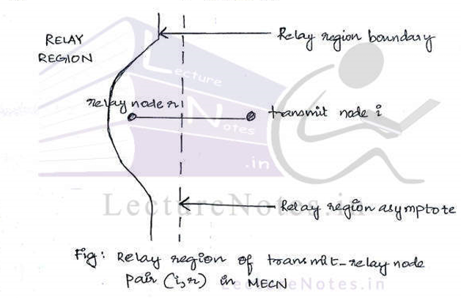
In this way ,global minimum power paths are found without considering all the nodes in the network.
The protocol has two phases:-
- Construct a sparse graph( enclosure graph) which consists of all the enclosures of each transmit node in the graph.
- Finds optimal link on the enclosure graph. It uses distributed Bellmann-Ford shortest path algorithm with power consumption as the cost metric.
- The small minimum energy consumption communication network(MECN) is an extension of MECN.
- The advantage of such topology with smaller number of edges is primary reduced cost for link maintenance .
- Minimum common power setting(COMPOW)
The COMPOW protocol ensures that the lowest common power level that ensures maximum network connectivity is selected by all nodes. A number of arguments can be made I favor of using a common power level that is as low as possible at all nodes: (i) it makes the received signal power on all links symmetric in either direction (ii) it can provide for an asymptotic network capacity which is quite close to the best capacity achievable without common power levels: (iii) a low common power level provides low-power routes: and (iv) a low level minimizes contention.
The COMPOW protocol works as follows: first multiple shortest path algorithms (e.g. distributed Bellman-Ford algorithm) are performed, one at each possible power level. Each node then examines the routing tables generated by the algorithm and picks the lowest power level such that the number of reachable nodes is the same as the number of nodes reachable with the maximum power level.
The COMPOW algorithm can be shown to provide the lowest functional common power level for all nodes in the network while ensuring maximum connectivity, but does suffer from some possible drawbacks. First it is not very scalable , as each node must maintain a sate that is of the order of the number of nodes in the entire network. Further , by strictly enforcing common powers, it is possible that a single relatively isolated node can cause all nodes in the network to have unnecessarily large power levels.
3.Minimizing maximum power:- a work by Ramanathan and Rosales-Hain presents exact as well as distributed algorithms that seek to generate a connected topology with non uniform power levels , such that the maximum power level among all nodes in the network is minimized.
4.Cone-based topology control(CBTC):- The cone based topology control technique provides a minimum direction -based distributed rule to ensure that the whole network topology is connected, while keeping the power usage of each node as small as possible. The cone based topology construction , is very simple. And it involves only a single parameter ‘ ‘ the cone angle. In CBTC each node keeps increasing its transmit power until it has one neighboring node in every or it reaches its maximum transmission power limit. It is assumed here that the communication range increases monotonically with transmit power.
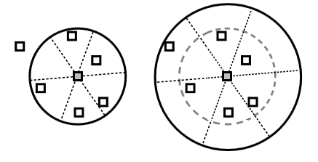
In the CBTC construction on the left we see an intermediate power level for a node at which there exists an cone in which the node does not have neighbor, therefore as seen on the right the node must increase its power until at least one neighbor is present in every .
CBTC showed that <=2π/3 to ensure that network is connected.
A tighter result has shown that can further be reduced to <=5π/6.
If <=5π/6 , then the graph topology generated by CBTC is connected, so long as the original graph , where all nodes transmit at maximum power , is also connected, if >5π/6 then disconnected topologies may result with CBTC.

COVERAGE METRICS
The term coverage indicates two things: the area of communication covered by the network or the area that can be observed by the sensors in a sensor network. Connectivity metrics are generally application specific. In most networks the objective is simply to ensure that there exists a path between every pair of nodes. At most, if robustness is a concern, the K-connectivity metrics may be used. However the choice of coverage metric is much more diverse and depends highly upon the application.
Two qualitative different sets of coverage metrics that have been considered are :-
1.K-coverage metrics- that measures the degree of sensor coverage overlap
2. Path –observability metrics- suitable for applications involving tracking of moving objects.
1. K-coverage
This metric is applicable in contexts where there is some notion of a region being covered by each individual sensor. A field is said to be K-covered if every point in the field is within the overlapping coverage region of at least K sensors.
Definition : consider an operating region A with n sensor nodes, with each node I providing coverage to a node region $A_{i}∈A$ (the node regions can overlap). The region A is said to be K-covered if every point p$∈A$ is also in at least K node regions.
To determine that an area is K-covered is to divide the area into a grid of very fine granularity and examine all grid points through exhaustive search to see if they are all K-covered. In an s x s unit area, with a grid of resolution $∈$ unit distance, there will be 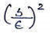 such points to examine, which can be computationally intensive. A more sophisticated approach would attempt to enumerate all subregions resulting from intersection of different sensor node –regions and verify if each of these is K –covered.
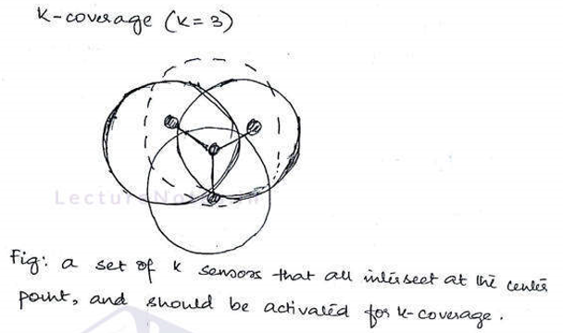
Coverage is a measure of how well the network can cover an event. The worst case coverage defines area breach where coverage is poorest. A path along the area of worst coverage is called maximum breach path . this can be used to improve the deployment of network. The best case coverage defines the area of best coverage. A path the along the area of best coverage is called maximum support path or maximum exposure path.
- Path observation
One class of coverage metrics that has been developed is suitable primarily for tracking targets or other moving objects in the sensor field. A good example of such a metric is maximum breach distance metric. Consider for instance a WSN deployed in a rectangular operational field that a target can traverse from left to right. The maximum breach path is the path the maximize the distance between the moving target and the nearest sensor during the targets point of nearest approach to any sensor. Given a deployment , how well can an adversary with full knowledge of the deployment avoid observation ?
Given a sensor field, and a set of nodes on it, the maximum breach path is calculated in the following manner:-
- Calculate the voronoi tessellation of the field with respect to the deployed nodes, and treat it as a graph. A voronoi tessellation separated the field into separate cells, one for each node, such that all points within each cell are closure to that node than to any other.
- Label each voronoi edge with a cost that represents the minimum distance from any node in the file to that edge.
- Add a starting node to the graph to represent the left (right) side of the field, and connect it to all vertices corresponding to intersection between Voronoi edges and the left (right) edge of the field. Label these edges with zero cost.
- Using a dynamic programming algorithm, determine the path between the starting and ending nodes of the graph that maximizes the lowest-cost edge traversed. This is the maximal breach path. The Label of the lowest –cost edge is the maximal breach distance.
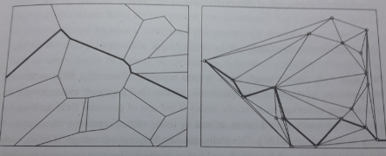
- (b)
- Maximal breach path through Voronoi cell edges
- Minimal support path through Delaunay triangulation edges
In the above figure (a) there can be several maximal breach paths with the same distance. Given a deployment the above algorithm can be used to determine the maximal breach distance, which is a worst-case coverage metrics. Such an algorithm can be used to evaluate different possible deployments to determine which one provides the best coverage.
Unlike the maximal breach distance, which tries to determine worst case observability of a traversal by a mobbing object, the maximal support distance aims to provide a best-case coverage metric for moving object. The maximal support path is the one where the moving node can stay s close as possible to sensor nodes during its traversal of the covered area. Formally it is the path which tries to minimize the maximum distance between every point on the path and the nearest sensor node. It turns out that the maximal support path can be calculated in a manner similar to the breach path, but this time using the Delaunay triangulation , which connects all nodes in the planar field through line segments that tessellate the field into a set of triangles , since Delaunay edges represent the shortest way to traverse between any pair of nodes , it can be shown that the least one maximal support path traverses only through Delaunay edges. The edges are labeled with maximum distance from any point on the edge to the nearest source. A graph search or dynamic programming algorithm can then be used to find the path through the Delaunay graph on which the maximum edge cost is minimized given in figure (b) above.
Mobile Deployment
Several research efforts that have examined the problems of deployment with mobile nodes. One approach to ensuring non-overlapping coverage with mobile nodes is the use of potential field techniques , whereby the nodes spread out in an area by using virtual repulsive forces to push away from each other. This technique has the great advantage of being completely distributed and localized, and hence easily scales to very large numbers. A similar technique is the Distributed self-spreading algorithm(DSSA) . To obtain desirable connectivity guarantees, additional constraints can be incorporated , such as ensuring that each node remains within range of k neighbors.
An incremental self-deployment algorithms is that whereby a new location for placement is calculated at each step based on the current deployment, and the nodes are sequentially shifted so that a new deployment is created with a node moving into that new location and othe nodes moving one by one accordingly to fill any gaps. A bidding protocol for deployment of a mixture of mobile and static nodes is whereby , after an initial deployment of the static nodes , coverage holes are determined and the mobile nodes move to fill these holes based on bids placed by static nodes. A mutually helpful combination of static sensor nodes and mobile nodes is where a robotic nodes mobile explorations help determine where static nodes are to be deployed and the deployed static node then provides guidance to the robot’s exploration. The deployment of static sensor nodes from an autonomous helicopter is where the sensor nodes are first dropped from the air and self-configure to determine their connectivity. If the network is found to be disconnected, the helicopter is informed about where to deploy additional nodes.

